“Never worry about numbers. Help **one person** at a time, and always start with the person **nearest** you.”

“Everytime you SMILE at someone, it is an action of LOVE, a GIFT to that person, a beautiful THING.”

“Some people come in your life as **blessings**.

Some come in your life as **lessons**.”

“**Peace** begins with a **smile**.”

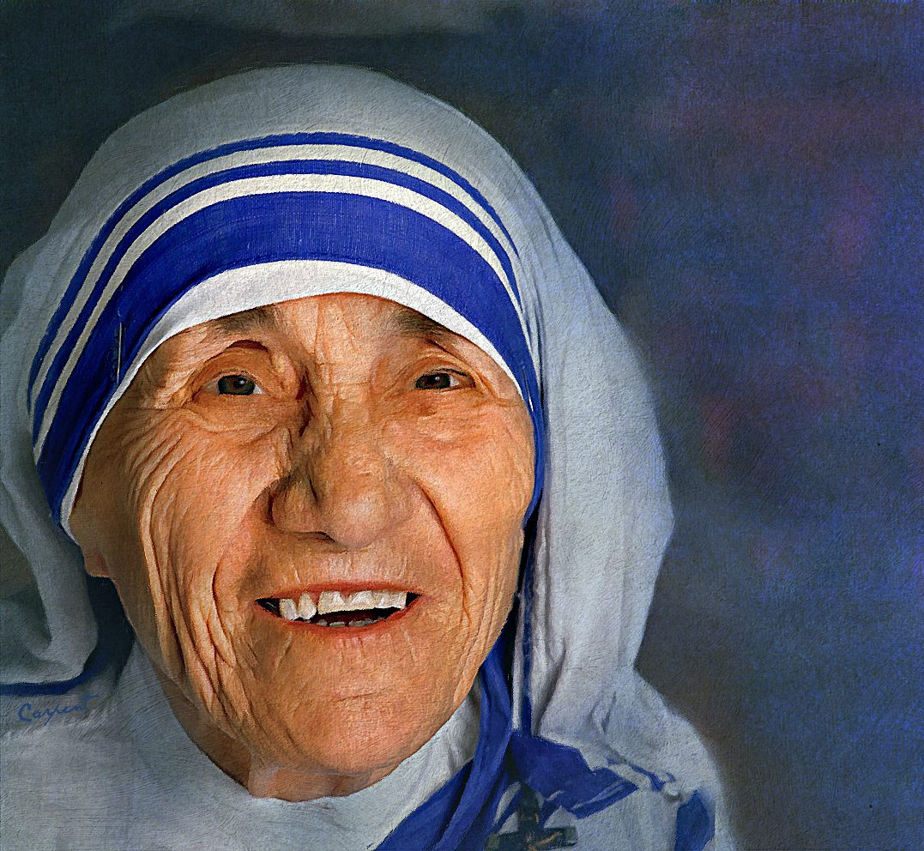

“The most terrible poverty is loneliness, and the feeling of being unloved.”

“Life is an **opportunity**, benefit from it.

Life is **beauty**,

admire it.”

“If you want to **change the world**, go home and **love your family**.”

“We shall never know all the good that a simple **smile** can do.”

“If you can’t feed a hundred people, then just feed one.”

“Kind words   
can be short and easy to speak,   
but their **echoes** are truly   
**endless**.”

“If we really want to LOVE   
we must learn how to FORGIVE.”

“Not all of us can do **great things.**

But we can do **small things** with **great love.**”

“Spread **love** everywhere you go. Let no one ever come to you without leaving **happier**.”

## "God doesn't require us to succeed, he only requires that you try."

"We ourselves feel that what we are doing is just a drop in the ocean.   
But the ocean would be less because of that missing drop."

“Intense love does not measure, it just GIVES.”

"The more you have, the more you are occupied, the less you give.

But the less you have the more free you are."

“Reach high, for stars lie hidden in your soul. Dream deep, for every dream precedes the goal.”