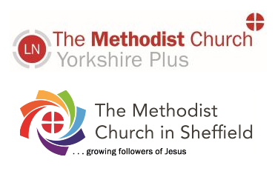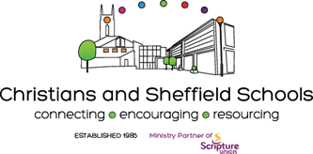

School Chaplaincy and
School Ministry Training Course 2022

Topics on the course will be covered by a wide range of specialist speakers. Topics include:
What difference can school chaplaincy make to the school community?
Being professional in the school setting
Understanding boundaries, limits and the school’s expectations
Children and spirituality, Spirituality in schools (SMSC)
Generation Z: their characteristics and the relevance of school chaplaincy
Understanding the school staff
Chaplain to all faiths and none
Basic Safeguarding (it is expected delegates will complete more in-depth training)
A basic introduction to Collective Worship, SMSC, RE, SACRE, British Values, Mentoring, School Governorship and the law surrounding them
An introduction to Mental Health
Listening
Issues young people face – gender, drugs, identity, loss and bereavement
An introduction to mentoring
Models of school chaplaincy and possible job descriptions
School chaplaincy scenarios
Support and resilience for school chaplains and those they serve
Resources for school chaplaincy & using ‘the third space.’
RE and school chaplaincy

