Memory page

Happy Memories



1. What will you miss about this school?
2. How will you be remembered? – YOUR LEGACY
3. What is the favourite trip you have had at this school?

Write or draw something that you have enjoyed doing at school.

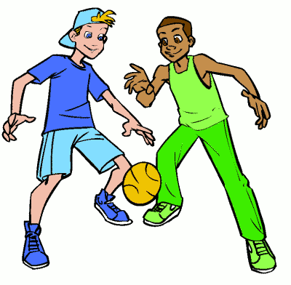

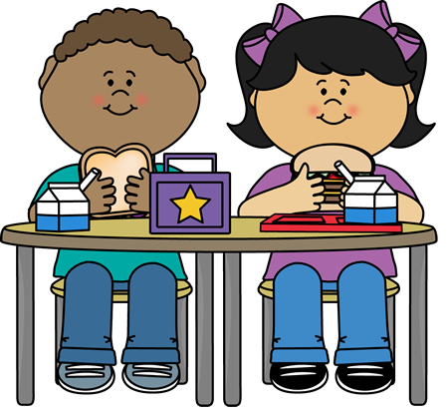

What do you like to eat / do at lunchtime?

Draw it here.

Lunch time – Break - Play

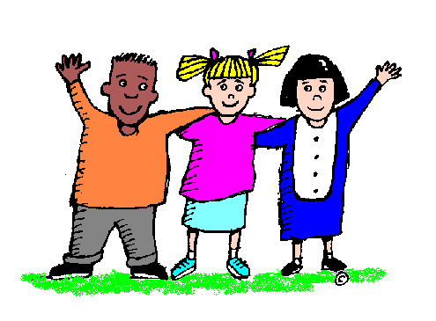

Think about 3 people who have been special to you while you have been at this school.

You can make a friendship bracelet to remind you of them.

Put the names of the people who have been special to you.

1.

2.

3.

Special People

*Remember…Sometimes asking for help is the bravest move you can make. You don’t have to go it alone.*



Starting school

Who might help you?

What are you going to miss/ what are you scared about when you move up to secondary school?

Moving on

On the footprint write about something you remember about starting school….



It’s Your Move

Looking Back

Thinking Forward

Be brave. Be strong. Don’t give up. (Psalm 31:24)

Being a best friend is more than sharing a joke, a conversation, a cup of coffee or a funny story. It means sharing an honest and true part of yourself.

“To accomplish great things, we must not only act, but also dream; not only plan, but also believe” (Anatole France)

Do small things with great love.

Hate what is wrong. Hold tightly to what is good (Romans 12:9)

Faith is taking the first step even when you don’t see the whole staircase. Martin Luther King Jr.

Remember

Name

___________________________

Teacher’s name

___________________________